Dashboard Design
Field | Value
Team ID | MCA
Project Name | Strategic Employee Attrition Intelligence Dashboard
Maximum Marks | 5 Marks

Creating an effective dashboard involves thoughtful design to ensure that the presented information is clear, relevant, and easily understandable for the intended audience. Here are some key principles and best practices for dashboard design:
Activity 1: Interactive and visually appealing dashboards
Creating interactive and visually appealing dashboards involves a combination of thoughtful design, effective use of visual elements, and the incorporation of interactive features. Here are some tips to help you design dashboards that are both visually appealing and engaging for users, so take care of below points:
- Clear and Intuitive Layout
- Use Appropriate Visualizations
- Colour and Theming
- Interactive Filters and Slicers
- Drill-Down Capabilities
- Responsive Design
- Custom Visuals and Icons
- Use of Infographics

Dashboard Conceptual Interface Preview
Below is the structural framework mapping our core workforce metrics (5,000 total records) and retention drivers into an executive visual control interface:
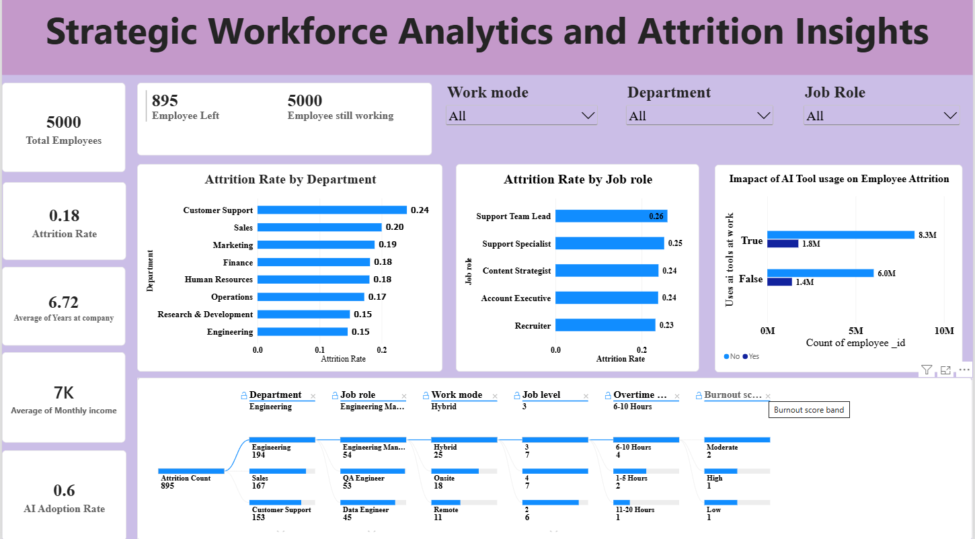

Note: Highlight the major outcomes in form of bullet points
Sample:
Here are five potential outcomes from the dashboard image provided:
- Total Tracked Headcount: The system monitors an organizational footprint of 5,000 corporate employees, establishing a comprehensive baseline for risk segmentation.
- Macro Attrition Index: The interface isolates an official turnover velocity of 17.9%, visually flagging the metric to prioritize strategic retention budgets.
- Exited Personnel Matrix: A dedicated volume metric maps the exact 895 historical departures, providing clean target labels for predictive machine learning models.
- Driver Predictive Weighting: The feature column rankings highlight that Compensation Satisfaction and Workload Balance serve as the strongest statistical triggers for employee flight.
- Work Arrangement Vulnerability: Risk filters across categorical channels display distinct hazard concentrations between Fully Onsite, Hybrid, and Fully Remote work arrangements.

